Great news that you are interested in Research

As a trust we are running around 80 recruiting trials at any one time, this does vary. We have trials in most specialities on both sites.
We do not currently have any open home-grown research and all our trials are ones we host for a wide variety of sponsors – we are hoping to change this and have research fellows developing proposals as you read... please watch this space
We would like to help you get involved so have split the information between A and B below
Which one are you?

A Interested in writing your own research/developing a research idea?
Or
B
Gaining research experience by getting involved with one of the trials we already have open relevant to your clinical area?

A
Developing a research Idea?

Knowing whether your project is research is a good first step
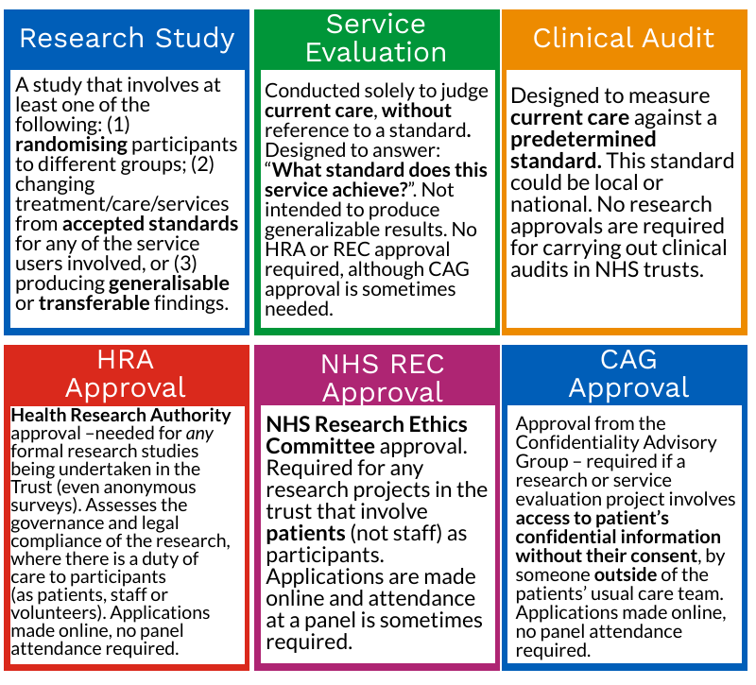

HRA have a handy decision tool to further help you –Do I need NHS Ethics approval? (hra-decisiontools.org.uk)

This chart will also help Information for Researchers (royalwolverhampton.nhs.uk)
There is a clinical trials toolkit with handy routemap to be found here Routemap (ct-toolkit.ac.uk)
Also the Research design service Research Design Service | NIHR they have produced this useful leaflet https://www.rds-wm.nihr.ac.uk/pdfs/RDS%20CRN%20final.pdf

Once you have a good look through all of this, please feel free to get in touch with Rachel or Bec sath.research@nhs.net for more help

B
Getting onboard with an existing study

If you are a trust doctor, Junior Doctor, Nurse, midwife or AHP at SATH then doing your Good Clinical Practice GCP course is a must if you would like to get involved in research.
The best way is online and can be done here Identity Gateway (nihr.ac.uk) where you first register for an NIHR learn account and then select the course introduction to GCP
Once done please send a copy of your certificate to sath.research@nhs.net and we will then send you a research CV template to complete
The next step is to find a study to work on that suits your interests and area – you can do this by finding out which studies are currently recruiting patients at SATH
Clinical Research Network West Midlands Digital Portfolio Maps (google.com)
Be Part of Research (nihr.ac.uk)
You can get involved if there is a study in your clinical area that is open and recruiting by taking on a role within that study - for some studies there is the option of being a sub or co -investigator with the permission of the Principal investigator (PI) – this is at their discretion if they feel you have the right skills and experience to support them and if you have the right time commitment to make this valuable.
They might allow you to become Associate PI for the study if their study is part of this excellent scheme
See more here : Associate Principal Investigator (PI) Scheme | NIHR

There is only one associate PI per study per site so you may need to find out if someone is already carrying out this role – we can help you with this or speak to the local PI.

We do have an everchanging portfolio of research studies open so if you cannot find one that suits right now it is worth checking back or even scanning the portfolio Clinical Research Network West Midlands Digital Portfolio Maps (google.com) and considering becoming a PI yourself if you feel you are able to deliver a study in your clinical area.

Our research nurses/midwives maybe able to support you if they have capacity and we run regular PI masterclass sessions for you to network with other local PI’s and learn more about the role

We want to make SATH a proactive research environment and hope to harness all your research enthusiasm by turning it into improvements in care for the future

Neither A nor B suit?

If you feel you do not have the time to commit at this level but would like to know more about what we do then there is a possibility of shadowing – this could be with a research nurse, research fellow or PI and would generally be for a day or less depending on study activity and time restrictions
We also run PI masterclass training and we are looking at other training to provide you with what you need
All feedback on this is welcome and please email to Mandy Carnahan @ m.carnahan@nhs.net

If you have other questions such as getting involved as a volunteer or research champion
then please get in touch sath.research@nhs.net

