How to complete an Exit Questionnaire

When a termination (full or part) is processed on ESR an automatic email will be generated and sent directly to your nhs.net email. This will request for you to access your ESR Employee Self Service record to access a notification.

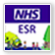
- Access ESR using the following:

- ESR app on the Intranet.
- The Internet link is http://my.esr.nhs.uk.
- The SaTH App from a mobile or tablet device http://tiny.cc/sathnhs

- The My ESR app from a mobile or tablet device

- Login to ESR using your Username and Password.

- Click the Notifications icon on the My ESR Dashboard and the worklist will be displayed.

- Click on the notification link, in this example ‘Exit Questionnaire for: (Employee Name).

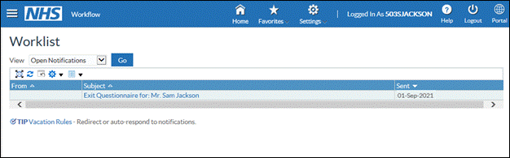

- The Exit Questionnaire will open, select the applicable response from the list of values available in the drop down list. Any further comments can be added in the textbox at the end of the notification.

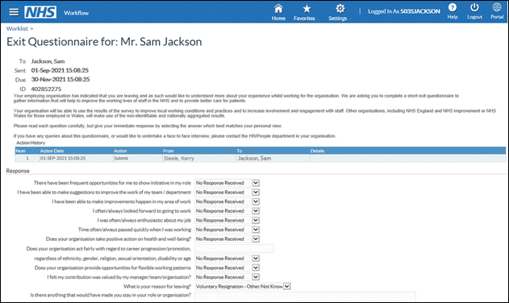

- Click the Submit button to continue.

- Note – you must complete this questionnaire before your termination date, after this date you will not be able to access your ESR employee self service record.

