Work Experience Directory

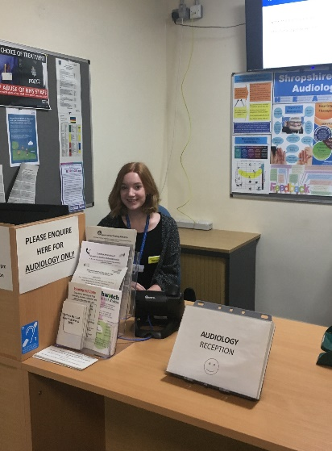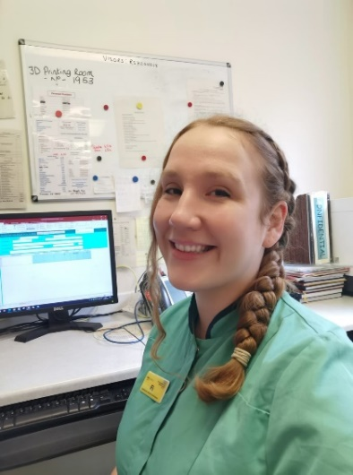

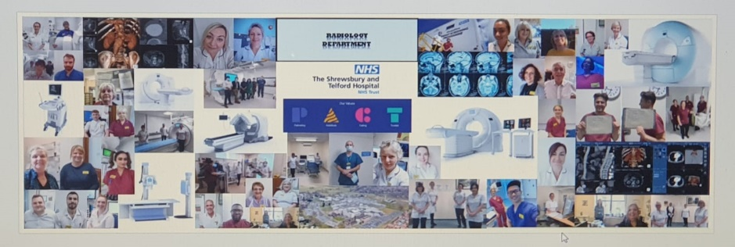

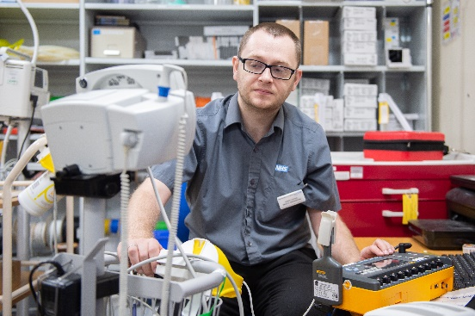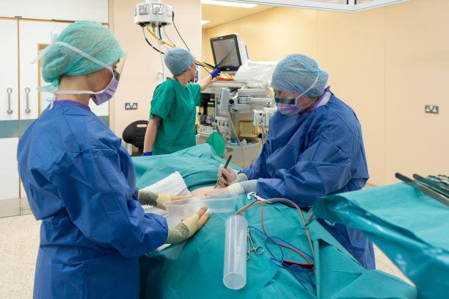

This directory lists all the departments and job roles the Trust can offer work experience placements in. Should you have any specific career aspirations that are not listed here please contact us via sath.wideningparticipation@nhs.net
The Trust has a centralised process for work experience applications therefore all work experience applications MUST come via this process. Individually arranged placements will not be accepted.
Due to the demand for placements, we unfortunately must restrict applications to one placement during each academic year. You can identify up to three areas that you would be interested in having a placement in that supports your career path. We will then liaise with managers within these areas to see if they are able to accommodate your requests and let you know within six weeks of application. If after this time you have not heard from us, please contact sath.wideningparticipation@nhs.net
All departments outlined in this directory are risk assessed and comply with the Trust’s Health and Safety Policy.
We are not able to offer placements in areas that have not been through this process.
How to apply for a work experience placement:
- Using this directory decide which department or job role you wish to have you placement opportunity with.
- Complete an application form and self-declaration form – see Trust website www.sath.nhs.uk or www.belongtosomething.co.uk
- Fully completed forms should be sent to: sath.wideningparticipation@nhs.net
Unfortunately, due to the demand for placements we are only able to offer an opportunity to those who live within Shropshire, Telford and Wrekin.
For further information on the variety of careers which exist within the NHS please visit www.healthcareers.nhs.uk

Clinical services
Department | Placement information | Other information
Nursing | 5 day observational only. Working with various members of the ward team | Limited number of ward-based placements. Applications must be submitted at least 8 weeks before placement date. Applicants must be in Year 12 or above.
Pharmacy | Anything from a day to a week.  An all-round experience of working in Pharmacy. Spending time with each team, experiencing the work in the department and on the wards. Activities observed include dispensing, issuing stock, replenishing stock on the wards, dispensing medication, taking medication histories for in-patients, speaking to patients about their medication and discharge preparations. | Sixth form upwards.  Placements available November and July
Cardio-Respiratory technician | All activities will be observational only.  - An insight into the career structure within cardio-respiratory  - Insight into how the department operates.  - An insight into heart and lung function testing using a variety of techniques and equipment. | Year 12 and above.  Excellent communication skills
Fertility Services | Placement duration of two days | Sixth form and above.  Interest in healthcare science career.
Radiotherapy | Placement duration up to one week.  During the placement you will gain an overview of radiotherapy treatment and the multidiscipline team that this entails | Sixth form and above
Audiology | Placement duration- maximum 3 days  Observation placement with a mixture of adults/paediatrics services. | Sixth form and above  Most suited to students who have a keen interest in science, technology but the main focus is patient interaction/communication
Radiology PRH | Observational placement only  Two days maximum  An overview of the various areas and roles within the department | Sixth form and above
Maxillofacial | Up to a week in duration  Participants will work in a lab setting taking part in various activities. Develop an understanding of the type of services supported and the training required to work within the department.
Medicine -  Shadowing a doctor | Placement length may vary on departments available.  shadowing a doctor(s) in a variety of settings within a hospital environment including clinics, ward work and if applicable theatres. | Sixth form and above
Midwifery | Placement duration one week.  Shadow healthcare workers to gain experience of the clinical environment | Sixth form and above
Laboratories | Placements may be available depending on activity within the department. | Sixth form and above
Therapies | Work experience placements are available across the Therapy Centre including Dietetics, Physiotherapy, Occupational Therapy, Speech & Language & Admin and individual requests will be considered. | Sixth form and above

Support Services
Department | Placement information | Other information
Catering (RSH) | 3 – 5 days  During the placement you will see the various departments within catering, patients meals/dining room servery/caffe bistro | Over the age of 15
Legal Services | Placement duration 1-2 weeks.  Support and observe work within the department. | Sixth form and above
Library Services RSH and PRH | Placement available from one day to one week.  During the placement you would:  - Take part in general library duties (shelving, issuing books, processing materials)  - Meet with members of the team to understand their role and responsibilities.  - Have the opportunity for involvement in more complex tasks.  - Learn about the role of libraries in a hospital environment. | Year 11 and above.  - Participants should have good attention to detail and an interest in information (print & electronic)  - Must have some computer skills.  - No safety clothing required but should dress smartly.
Clinical Audit | Placement one week in duration.  Tasks undertaken: Assist with general admin tasks, photocopying, filing, getting case notes.  With support produce PowerPoint presentations and scan audit forms. Attend meetings as an observer. | Age 16 upwards
Education Business Support Unit | Duration of placement from one day to one week.  Support with general business support e.g. scanning of health declarations, printing of course material, creating promotional posters. Observation of LMS systems, organising mandatory training programme.  Opportunity to observe mandatory training sessions and other training taking place, observe lots of customer service, telephone and face to face support. Opportunity to develop their CV skills and interview guidance. | Year 10 and above
Porters – PRH | Duration of placement- no longer than one week. | Year 10 and above
Improvement Team | Placements available throughout the year. Duration of placement can be 1 day to a maximum of 5 days.  Will participate in Improvement training (including bitesize videos)  Improvement activities  Improvement planning meetings | Year 12 and above
Finance | During the placement you will experience the day to day running of the department with an opportunity to spend time in financial management, financial accounts, payroll, accounts payable and accounts receivable teams.  You will meet the members of the teams and understand their roles and responsibilities and have the opportunity to shadow finance staff in live meetings.  You will gain an insight into NHS finance and undertake individual tasks such as data analysis. | Open to Year 10 and above students with an interest in pursuing a career in NHS Finance.

