**Introduction**

**The Shrewsbury and Telford Hospital NHS Trust are one of the region's largest employers. We are proud to have a diverse workforce of 8096 substantive colleagues, expanding to 9582 when including bank workers.**

The Shrewsbury and Telford Hospital NHS Trust is the main provider of district general hospital services for nearly half a million people in Shropshire, Telford & Wrekin and mid Wales. Our main service locations are the Princess Royal Hospital in Telford and the Royal Shrewsbury Hospital in Shrewsbury, which together provide 99% of our activity.

Both hospitals provide a wide range of acute hospital services including accident & emergency, outpatients, diagnostics, inpatient medical care and critical care.

**We are committed to reflecting the communities we serve and fostering strong partnerships within our healthcare network.**

**To attract and retain top talent, we offer a wide range of career opportunities across all professional groups and levels. We are dedicated to creating an inclusive workplace where everyone feels valued and supported. By regularly reviewing our gender pay gap, we are actively working to address any inequalities and ensure a fair and equitable environment for all.**

**Background.**

Gender pay reporting is mandatory under UK law (Equality Act 2010). This report data illustrates the earnings gap between male and female employees at our organisation.

The gender pay gap shows the difference in the average hourly rate of pay between men and women. A gender pay gap can be driven by several factors including, crucially, underrepresentation of women in senior positions.

We use this information to assess:

* Gender equality across our workforce
* Representation of men and women at different pay levels
* Our effectiveness in recognising and rewarding talent.

**Important points of note:**

* **Gender pay gap is not the same as unequal pay.** Equal pay for equal work is a separate legal requirement.
* **Our current records do not include non-binary gender identities**. We fully acknowledge and respect the diversity of gender identities, including non-binary and transgender individuals.
* **The** **public sector deadline for publication of the data** is 31st March each year, with calculations based on a ‘snapshot date’ of the previous 31 March.

**Our headline Gender Pay Gap data**

* Our mean gender pay gap is 19.92%. The median gender pay gap is 6.57%. This is inclusive of our Medical and Dental colleagues.

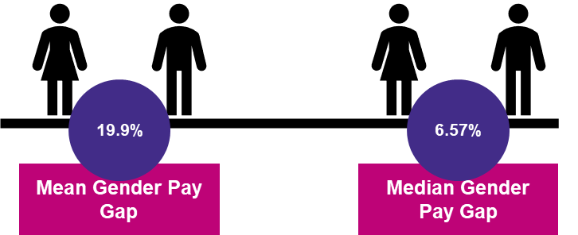

**Mean average Rates of Pay by Gender in The Shrewsbury and Telford Hospital NHS Trust – All staff (inclusive of Medical and Dental)**

To calculate the mean pay gap, we add together all the hourly pay rates that women received, divided by the number of women in our workforce. We then repeat this calculation for men. The difference between these figures is the mean gender pay gap.

The hourly rate is calculated using "ordinary pay," which includes basic pay, allowances, and shift premium. Our pay rates exceed the national living wage.

**This means women earn 80p for every £1 that men earn when comparing mean hourly pay.**

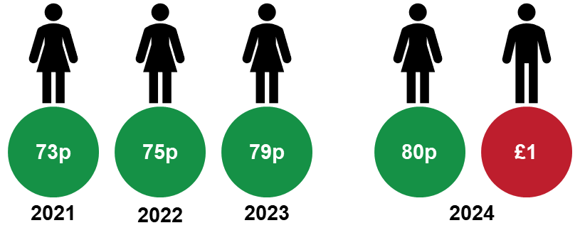

**Our overall mean pay gap has dropped every year consecutively since 2021. In this 4-year period we have seen the gap close by 6.58% and 1.15% year on year.**

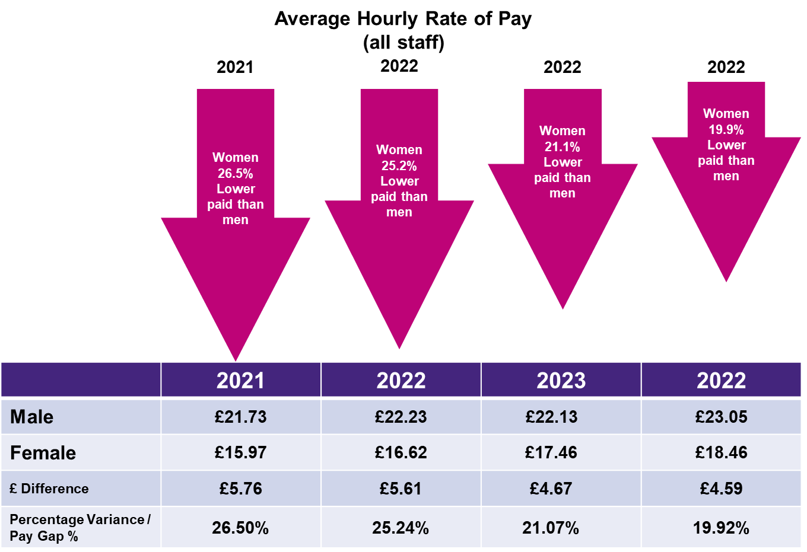

* Female colleagues in positions that are non Medical and Dental are paid more than their male counterparts and have been for the last 3 years.

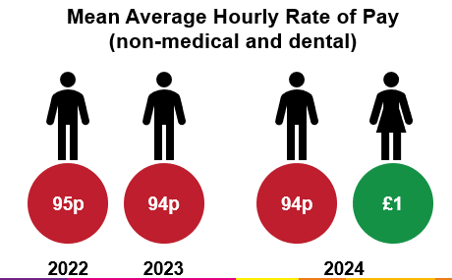

* Within our Medical and Dental workforce, males are paid 9 pence more than females. This has decreased by 2 pence since 2023.

**Median average Rates of Pay by Gender in The Shrewsbury and Telford Hospital NHS Trust – All staff (inclusive of Medical and Dental)**

To calculate our median gender pay gap, we first rank all our people by their hourly pay. Then we compare what the woman in the middle of the female pay range received with what the man in the middle of the male pay range received. The difference between these figures is the median gender pay gap.

**When comparing median hourly pay women earn 93p for every £1 that men earn**

Our overall median pay gap has been gradually narrowing. However, this year has seen a slight increase since 2023. Contributing to this could be the fluctuations in the number of men working in the Trust increasing by 2% year on year.

**Understanding our Gap**

The difference between the average (mean) and middle value (median) pay gap within an organisation can shed light on the factors influencing the overall pay gap. If an organisation has a large number of low-paid employees, the average pay gap will be pulled down, making it smaller than the median. Conversely, if an organisation has a small number of very high-paid employees, the average pay gap will be pulled up, making it larger than the median. This is the case in Shrewsbury and Telford hospital.

Our Trust gender profile is 77.31% female and 22.38% male (Table 1). The number of males has increased year on year at varying levels of pay in the Trust. Band 2 and 8b representation has seen the highest increases at 3% and 4% respectively. (Table 2)

If we look at the pay quartiles across the Trust, we can see a mixed representation of levels. With the highest quartile seeing the largest representation of males at 31.22% which is an increase of 1.21 since 2023. (Table 3). Interestingly the number of males in all quartiles has increased since 2023. Women are most highly represented in Quartile 3 and men in Quartile 4.

**Table 1 Gender mix in The Shrewsbury and Telford Hospital NHS Trust as of 31/03/2024**

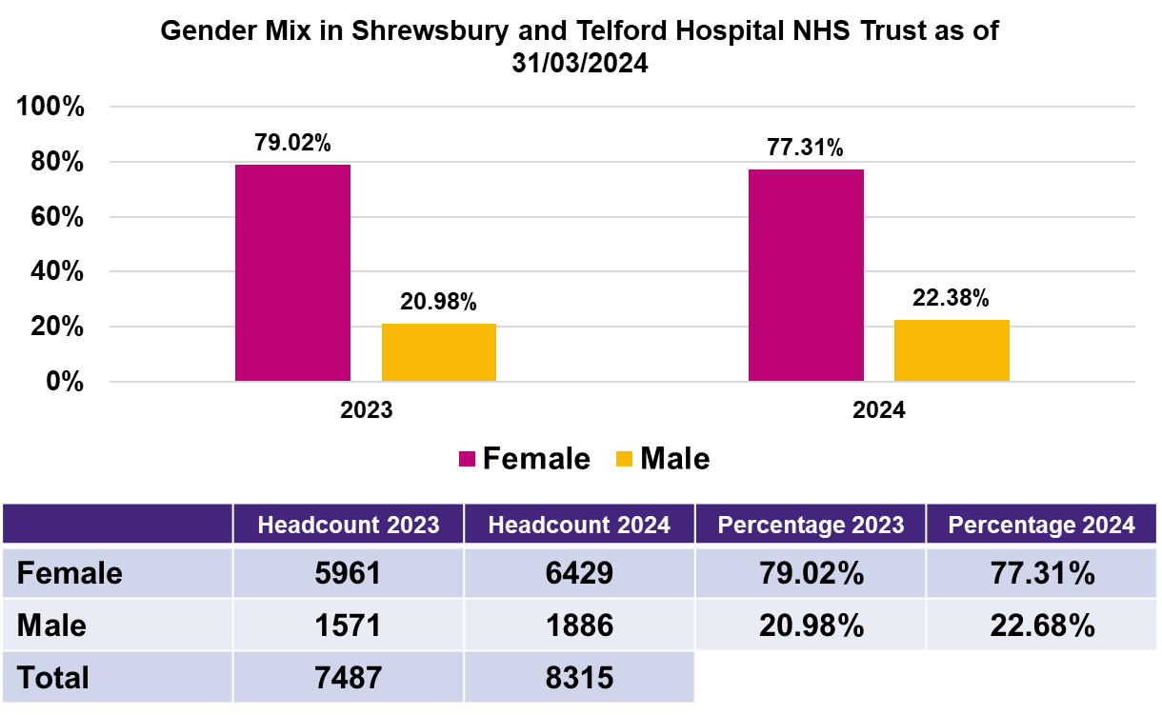

**Table 2 the Gender mix at pay band level within The Shrewsbury and Telford Hospital NHS Trust as of 31/03/2024 year on year performance.**

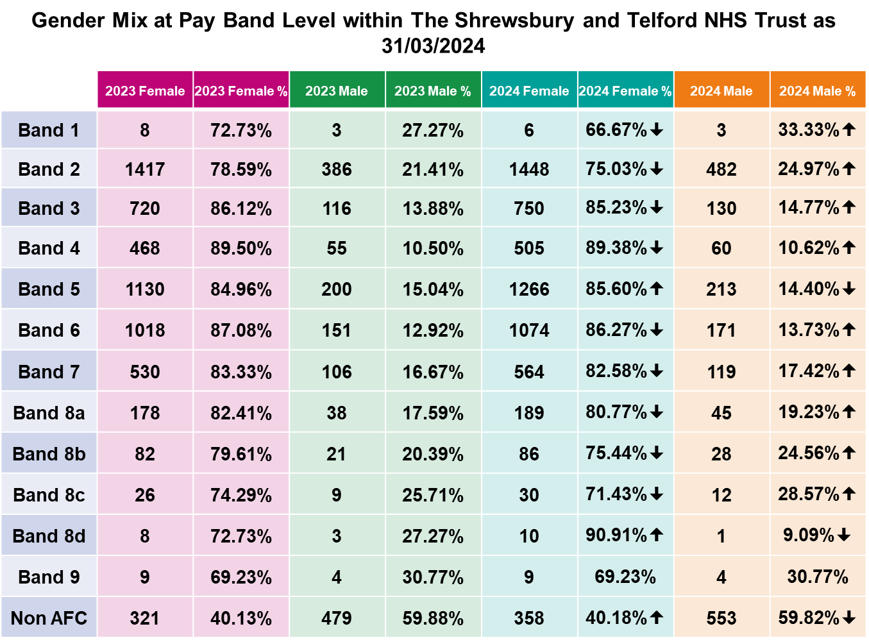

**Table 3 2024 Pay Quartile all Staff (including Medical and Dental)**

This method splits the proportions of male and female full-pay relevant employees in the lower, lower middle, upper middle and upper quartile pay bands (Quartiles 1, 2, 3 and 4). The make up between the quartiles has seen the highest percentage increase in the number of females in the lowest quartile year in year and Quartile 2 has seen the highest number of males join the organisation. As a further observation, 476 colleagues have either changed quartiles or been recruited into the Trust. 307 of these were female and 169 males. For females, 29% (89 colleagues) of those were in quartile 4 and for males was in Quartile 2 at 39% (66 colleagues).

|  |  |  |  |  |  |  |  |  |
| --- | --- | --- | --- | --- | --- | --- | --- | --- |
| **Quartile** | **2023 Female** | **2023 Female %** | **2024 Female** | **2024 Female %** | **2023  Male** | **2023  Male %** | **2024  Male** | **2024  Male %** |
| **1** | **1389.00** | **79.37%** | **1475.00** | **79.09%** | **361.00** | **20.63%** | **390.00** | **20.91%** |
| **2** | **1403.00** | **80.08%** | **1457.00** | **77.83%** | **349.00** | **19.92%** | **415.00** | **22.17%** |
| **3** | **1492.00** | **85.21%** | **1570.00** | **83.82%** | **259.00** | **14.79%** | **303.00** | **16.18%** |
| **4** | **1518.00** | **86.64%** | **1607.00** | **85.89%** | **234.00** | **13.36%** | **264.00** | **14.11%** |

**Bonus Pay Gap**

The Trust does not provide traditional performance-based bonuses. For the purposes of gender pay gap reporting, national and local Clinical Excellence Awards (CEAs), **which are exclusively awarded to medical and dental consultants**, are categorised as bonus payments. Prior to the COVID-19 pandemic, CEAs were granted competitively to recognise exceptional contributions to quality and excellence. However, in response to the pandemic, NHS Employers, in conjunction with the British Medical Association (BMA), directed NHS Trusts to distribute local CEA funding equally among eligible consultants to optimise clinical and managerial capacity for patient care.

On reviewing the old Clinical Excellence Awards data which was pre-2018 when the awards were consolidated and paid for the duration of your career, this demonstrated 99 doctors having an old Clinical Excellence Award of which 28 of these were women which demonstrates 28% were in possession of an award however it was interesting to note that only 2% of females had a level 5-9.  When comparing this to the equal split of the new local Clinical Excellence Awards post-2018 which were non-consolidated, and time limited which demonstrated 35% of our doctors are female with 34% being eligible to receive an award.

**For this year’s award**:

* 294 doctors were employed with 274 meeting the eligibility criteria for the award.
* 103 of those were females, 93 were eligible for the award equating to 34% of the workforce.
* 46 of the 274 headcounts were less than full time (LTFT) 17%
* 25 of the 46 LTFT were female 54%.

The median gender pay gap (excluding historic bonus) has been eliminated, reflecting the non-competitive nature of the process that awarded equal-value local CEAs to a greater number of consultants this year. When including the historic pre 2018 data, the gap is 43%.

The total number of men in the organisation that received a bonus payment is 3.3% and women is 0.3% as a total of the headcount.

The mean bonus pay gap is 43.45%. This disparity is primarily due to the underrepresentation of female consultants in receipt of the pre 2018 CEAs. Additionally, the mean bonus pay gap is skewed by the disproportionate number of male consultants receiving these higher-level pre 2018 CEAs. This is the final year the local award will be applied. Next year there will be a change to the consultant pay from April [Consultant doctors and dentists pay progression system guidance | NHS Employers](https://gbr01.safelinks.protection.outlook.com/?url=https%3A%2F%2Fwww.nhsemployers.org%2Fpublications%2Fconsultant-doctors-and-dentists-pay-progression-system-guidance&data=05%7C02%7Cvicki.robinson1%40nhs.net%7Cc670752926ec443c8b4f08dd093f2b8e%7C37c354b285b047f5b22207b48d774ee3%7C0%7C0%7C638676889091074105%7CUnknown%7CTWFpbGZsb3d8eyJFbXB0eU1hcGkiOnRydWUsIlYiOiIwLjAuMDAwMCIsIlAiOiJXaW4zMiIsIkFOIjoiTWFpbCIsIldUIjoyfQ%3D%3D%7C0%7C%7C%7C&sdata=kGILnMGPvi2P5nKHic%2BTp76V%2BJKCxSjoTJRuegprYpI%3D&reserved=0).

**Our Mean bonus pay gap all tables.**

**Table 6**

**Conclusion**

We are pleased that our overall mean pay gap has decreased consecutively each year since 2021. Over this four-year period, we have seen a 6.58% (7 pence) reduction, followed by a 1.15% (1 pence) reduction year-on-year. Our annual staff survey, which asks "I am satisfied with my level of pay," has shown a positive trend, with a 10% decrease in dissatisfied female staff and an 8.44% decrease in dissatisfied male staff. While much of the rate of pay is beyond the Trust's direct influence, these figures demonstrate an improving trend in colleague satisfaction regarding pay levels.

The disparity between the mean and median pay gap indicates that the gap is primarily driven by a small group of high-earning male individuals. Despite being underrepresented in the overall workforce, male staff are overrepresented in the highest-earning positions, contributing significantly to the pay gap. When medical and dental staff are excluded from the calculations, a pay gap of 6 pence in favour of females is observed.

While the number of women in senior management positions has increased by 18%, this positive development has contributed to a narrowing of the pay gap. However, the complete elimination of the gap will necessitate sustained efforts, as the impact of increasing salaries for women in the upper quartile is partially offset by recent workforce changes.

**Reducing the Gender Pay Gap at The Shrewsbury and Telford NHS Trust**

The gender pay gap, is a persistent issue in many workplaces and here at The Shrewsbury and Telford NHS Hospital Trust, we are committed to closing that gap. We are proud to advance our initiatives in leadership development, promoting and shaping training and development opportunities, apprenticeship programs by collaborating with our staff networks, EDI steering groups, and ICS to ensure an equitable and inclusive workplace.

Our strategy for tackling our pay gap connects within pillar two of our People Strategy “Belonging in the NHS”. Progress will be governed and monitored under High Impact Action 3 (Eliminate total pay gaps with respect to race, disability, and gender) of the NHS six high impact actions improvement tool for Equality Diversity and Inclusion.

**Developing our people**

Providing a comprehensive suite of leadership development opportunities (Figure 1), accessible to all colleagues, is fundamental in addressing any pay gap. At SaTH, we believe we have achieved this through our various offerings. Our non-medical leadership development programs have seen 242 participants since their inception, of whom 201 were female (83%). Additionally, our Medical Leadership Development Training, introduced in 2022, has been offered to all medical leaders in post, with 76 completing the training, including 29 females (38%). This proportion aligns with the number of female senior medical staff within the organisation. To further support our colleagues' development, we offer a dedicated career portal, coaching and mentoring services, and apprenticeship schemes. Since 2018, 154 females and 20 males have accessed formal coaching and mentoring. In 2023, of the 26 colleagues who joined our apprenticeship schemes, 22 were female (85%).

**Fair and inclusive recruitment practices and transparent pay policies**

We are committed to fostering an inclusive workplace and promoting equitable opportunities for all employees. To achieve this, we continue to deliver "Safer recruitment" training to address unconscious bias and implement inclusive recruitment practices. We are also actively working towards becoming a Disability Confident Leader by making adjustments to our processes and practices, providing additional software such as CaptionED, Dragon Naturally Speaking, Global AutoCorrect, and TextHelp Read and Write, and supporting managers and staff through initiatives like the staff health passport and the sunflower scheme. We are currently developing a streamlined workplace adjustment process with clear guidance for managers. By collaborating with partners like the DfN (David Forbes-Nixon)* project, we offer supported internships and other valuable opportunities to support and train employees and managers. Furthermore, our implementation of the nationally agreed job evaluation scheme minimises the risk of bias and supports equal pay for work of equal value.

*DFN Project SEARCH is a one-year transition to work programme for young adults with a learning disability or autism spectrum conditions, or both.

**Figure 1**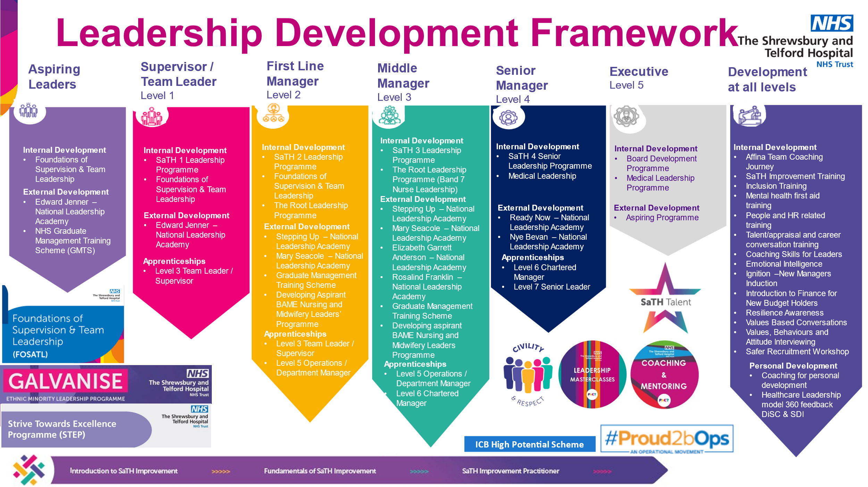

**Enabling a flexible working mindset**

Encouraging and supporting colleagues to work more flexibly at all levels within our organisation can contribute to a reduction in the Gender Pay Gap. By providing more options that empower staff members to have a greater say in where, when, and how they work, we can create more job and career opportunities, attract high-quality candidates, and retain a diverse workforce. Flexible working also contributes to enhanced work-life balance and overall well-being, reducing stress and absenteeism.

To support our staff and managers in embracing flexible working, our Flexible Working Group has introduced Flexible Working Masterclasses and Toolkit Briefings. These initiatives share the benefits of flexible working, provide success stories, and encourage creative thinking to identify practical options.

Our 2023 Staff Survey results demonstrate a strong correlation between increased flexibility and improved employee outcomes. Clinical areas that significantly increased their scores in the NHS People Promise element "We work flexibly" also experienced improvements in morale, engagement, reduced sickness levels, and turnover.

**Collaboration with external partners and our staff networks**

Staff networks play a vital role in creating and promoting a positive working environment, identifying areas for improvement, and celebrating successes. They are essential for enhancing a culture of inclusivity, ensuring that individuals feel empowered to bring their authentic selves to work. Our organisation is fortunate to have a range of vibrant staff networks that collaborate closely to influence decision-making and drive positive change. These networks include the Race Equality Network, PRIDE Network (LGBTQIA+), Disability and Long-Term Health Conditions Forum, DAWN (Disability, Ability, and Wellness Network), and our recently launched Multi-Faith and Belief Network. These networks provide valuable platforms for building a sense of community, fostering engagement, and taking action to address issues and promote inclusivity.

We also work across our own ICS and outside our region to share learning and benchmark our success in improving staff experience in our plight to improve staff experience and make Shrewsbury and great place to work and receive care.

By implementing these strategies, The Shrewsbury and Telford Hospital NHS Trust can take significant steps to reduce the gender pay gap, create a more equitable workplace, and promote gender equality within the organisation.