

Patient name:

Further information is available from:

Feedback
We appreciate and encourage feedback which can be shared in several ways through the hospital website. Scan the QR code to give feedback. https://sath.nhs.uk/patients-visitors/feedback/

Patient Advice and Liaison Service (PALS)
PALS will act on your behalf when handling patient and family concerns, they can also help you get support from other local or national agencies. PALS is a confidential service.
Royal Shrewsbury Hospital, Tel: 0800 783 0057 or 01743 261691
Princess Royal Hospital, Tel: 01952 282888

Other Sources of Information
NHS 111
A fast and easy way to get the right help, whatever the time. NHS 111 is available 24 hours a day, 365 days of the year.
111 (free from a landline or mobile)
www.nhs.uk
Self Help & Support Groups
A selection of websites providing access to good quality health information, local organisations and community groups is available from the library. www.library.sath.nhs.uk/find/patients/

Information in Other Languages or Formats
If you require this information in a different way such as easy read, a different language, larger print, audio or braille please tell a member of staff or contact the Patient Experience Team; sath.patientexperience@nhs.net or 01743 261000 ext. 2503
Hospital number:

Date when the
PIFU access will end:



Information for Patients

Auto-immune Neutropenia
Patient Initiated Follow up (PIFU)

d Follow up (PIFU)

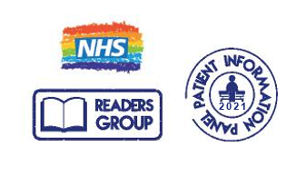
Website: www.sath.nhs.net

Information Produced by: Patient Access
Date of Publication: Jan 2022 Version: 1

Due for review on: Nov 2026 ID:
@SaTH NHS Trust
Our Vision: To provide excellent care for the communities we serve

What is ‘Patient Initiated Follow Up’ (PIFU)?

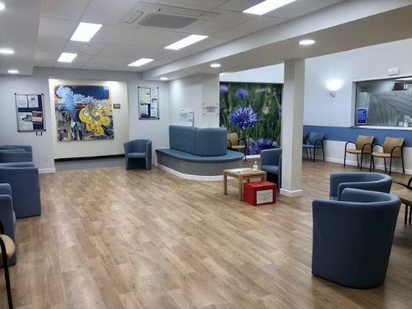

Patient initiated follow-up (PIFU) is a service which helps you to be in control and make your own decisions about appointments.

This leaflet gives you information about what PIFU is. It helps you decide whether you need to contact the Haematology Department for an appointment.

How PIFU benefits you
Your follow-up appointment if needed could be face to face or a phone call.

- Patient initiated follow up lets you be in control.
- You or your carer can arrange a follow up appointment when you feel you need one.
- You will have access to support if you need it.
- You can contact us up until the date shown on the front of this leaflet without contacting your GP.
- No need to travel to the hospital.

What symptoms should I get advice about?
Some of the more common symptoms to tell us about are:

• A fever, which is a temperature of 37.5°C or higher
- Chills or sweating
- Sore throat, sores in the mouth, or a toothache
- Abdominal pain
- Pain near the anus
- Pain or burning when urinating, or urinating often
- Diarrhea or sores around the anus
- A cough or shortness of breath
- Any redness, swelling, or pain (especially around a cut, wound, or catheter)
- Unusual vaginal discharge or itching
- Ear pain, swelling, discharge.

If you need urgent medical attention, you should phone 999. For medical problems which are not related to your Haematology condition please contact your GP or NHS 111.

How do I make contact?
Call the Haematology Department on the number given below. Please give your hospital number which can be found on the front of this leaflet.
To access PIFU, please call the Haematology Navigators on:

01743 261000 ext 2463

You can telephone from 9am to 5pm Monday to Friday, outside of these times there will be an option to leave a message.

