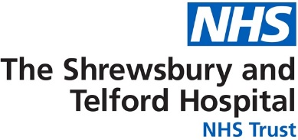

Patient name:

Further information is available from:

Feedback
We appreciate and encourage feedback which can be shared in several ways through the hospital website. Scan the QR code to give feedback. https://sath.nhs.uk/patients-visitors/feedback/

Patient Advice and Liaison Service (PALS)
PALS will act on your behalf when handling patient and family concerns, they can also help you get support from other local or national agencies. PALS is a confidential service.
Royal Shrewsbury Hospital, Tel: 0800 783 0057 or 01743 261691
Princess Royal Hospital, Tel: 01952 282888

Other Sources of Information
NHS 111
A fast and easy way to get the right help, whatever the time. NHS 111 is available 24 hours a day, 365 days of the year.
111 (free from a landline or mobile)
www.nhs.uk
Self Help & Support Groups
A selection of websites providing access to good quality health information, local organisations and community groups is available from the library. www.library.sath.nhs.uk/find/patients/

Information in Other Languages or Formats
If you require this information in a different way such as easy read, a different language, larger print, audio or braille please tell a member of staff or contact the Patient Experience Team; sath.patientexperience@nhs.net or 01743 261000 ext. 2503

Hospital number:



Information for Patients

Haematology CLL Stratified Follow up Pathway.

d Follow up (PIFU)

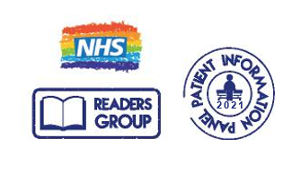
Our Vision: To provide excellent care for the communities we serve

Website: www.sath.nhs.net

Information Produced by: Patient Access
Date of Publication: Jan 2023 Version: 1

Due for review on: Jan 2024 ID:
@SaTH NHS Trust

Why have you been given this leaflet?

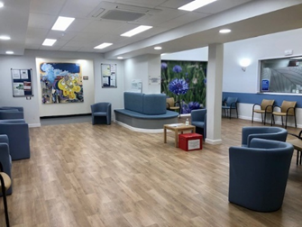
You have a health condition called Chronic lymphocytic leukaemia (CLL) is a cancer that affects the white blood cells called lymphocytes. It tends to develop very slowly.
You will be monitored by regular blood tests to check for any changes.
For this reason, you have been referred to the CLL Remote Monitoring Pathway.

What is ‘Remote (Stratified) Follow Up’?

Remote follow-up means appointments are replaced by checking your blood results remotely.
You do not have to come to hospital at times when you are feeling well.
The Haematology Department will send you a blood test form in the post every 6 to 12 months.
You can have the blood test at your GP surgery or at a hospital blood tests department.
We will let you know the results by letter.
Changes in the blood tests do not mean you have cancer however we might want to check your blood results more often, speaking to you over the phone or face to face in clinic.

How do I arrange a blood test?
To arrange blood tests, contact your GP surgery or:

Phone – 01743 492510
Email – www.sath.nhs.uk/bloodtests

Will I still be able to access the Haematology service?
If you have any questions, you can call our Navigator on the Helpline 01743 261000 Ext 2463. You can telephone from 8am to 4pm Monday to Friday. Outside of these times you will be able to leave a message (including your name and hospital number).
If the clinical team feel you need to be seen, you will be offered an appointment.

What are the signs and symptoms I need to look out for?

- getting infections often
- anaemia – persistent tiredness, shortness of breath and pale skin
- bleeding and bruising more easily than normal.
- a high temperature (fever)
- bone pain and night sweats
- swollen glands in your neck, armpits, or groin
- swelling and discomfort in your tummy
- unintentional weight loss

Please contact us if you have any new problems or concerns.

If you need urgent medical attention, you should contact NHS 111. For medical problems which are not to do with your Haematology condition please contact your GP or NHS 111.

