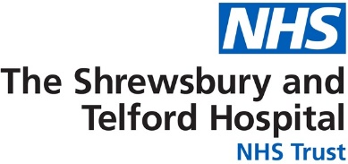

Patient name:

Further information is available from:

Feedback
We appreciate and encourage feedback which can be shared in several ways through the hospital website. Scan the QR code to give feedback. https://sath.nhs.uk/patients-visitors/feedback/

Patient Advice and Liaison Service (PALS)
PALS will act on your behalf when handling patient and family concerns, they can also help you get support from other local or national agencies. PALS is a confidential service.
Royal Shrewsbury Hospital, Tel: 0800 783 0057 or 01743 261691
Princess Royal Hospital, Tel: 01952 282888

Other Sources of Information
NHS 111
A fast and easy way to get the right help, whatever the time. NHS 111 is available 24 hours a day, 365 days of the year.
111 (free from a landline or mobile)
www.nhs.uk
Self Help & Support Groups
A selection of websites providing access to good quality health information, local organisations and community groups is available from the library. www.library.sath.nhs.uk/find/patients/

Information in Other Languages or Formats
If you require this information in a different way such as easy read, a different language, larger print, audio or braille please tell a member of staff or contact the Patient Experience Team; sath.patientexperience@nhs.net or 01743 261000 ext. 2503

Hospital number:



Information for Patients

Haematology Iron Deficiency Anaemia Remote Monitoring Follow up Pathway.

d Follow up (PIFU)

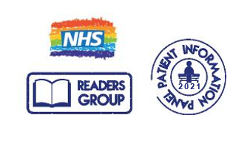
Our Vision: To provide excellent care for the communities we serve

Website: www.sath.nhs.net

Information Produced by: Patient Access
Date of Publication: May 2025 Version: 1

Due for review on: May 2026 ID: @SaTH NHS Trust

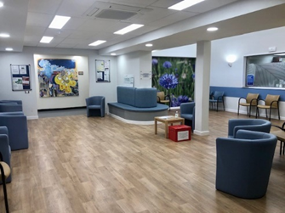
You have a health problem called Iron Deficiency Anaemia. The body does not have enough iron to produce enough red blood cells. This can lead to a decrease in the number of red blood cells or low haemoglobin. You will have regular blood tests to check for any changes. Due to this we have put you on the Iron Deficiency Anaemia Remote Monitoring Follow up Pathway.

What is Remote Follow Up?

Remote follow-up means you do not have to come to hospital for appointments. We can check your blood results remotely without needing to see you in person.
Every 6 to 12 months we will send you a blood test form in the post.
You can have the blood test at your GP surgery or at a hospital blood test department.
We will let you know the results by letter.
If there are changes in blood test results it does not mean you need any treatment. We might want to check your blood results more often, speak to you over the phone or see you in person.

How do I arrange a blood test?
To arrange blood tests, contact your GP surgery or:

Phone – 01743 492510
Website – www.sath.nhs.uk/bloodtests

Will I still be able to access the Haematology service?
Yes. If you have any questions, you can call the Navigator on 01743 261000 extension 2463. You can phone from 8am to 4pm, Monday to Friday. Outside of these times you can leave a message. Please tell us your name and hospital number. These are on the front of this leaflet.

What are the signs and symptoms I need to look out for?

Feeling very tired all the time, a lack of energy and general weakness

Shortness of breath or problems breathing, mainly during activity

If your skin goes Pale mainly on your face and inside your mouth

Headaches which may get worse with activity.

A feeling that your heartbeat is beating faster (palpitations) or missing beats

Nails that are thin, weak, and break easily

Your tongue may become sore and looks smooth

Having unusual cravings to eat non-food stuff such as ice, dirt, or clay.

Hands and feet may feel cold, even in warm spaces

A feeling of dizzy, being unsteady or faint.

Not wanting to eat (poor appetite).

Hair loss (in serious cases)

Please contact us if you have any other symptoms or concerns.

If you need urgent medical help, you should call NHS 111. For medical problems which are not to do with your Haematology health problem, please contact your GP or NHS 111 out of hours.

