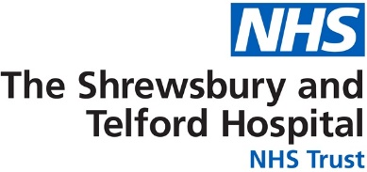

Patient name:

Further information is available from:

Feedback
We appreciate and encourage feedback which can be shared in several ways through the hospital website. Scan the QR code to give feedback. https://sath.nhs.uk/patients-visitors/feedback/

Patient Advice and Liaison Service (PALS)
PALS will act on your behalf when handling patient and family concerns, they can also help you get support from other local or national agencies. PALS is a confidential service.
Royal Shrewsbury Hospital, Tel: 0800 783 0057 or 01743 261691
Princess Royal Hospital, Tel: 01952 282888

Other Sources of Information
NHS 111
A fast and easy way to get the right help, whatever the time. NHS 111 is available 24 hours a day, 365 days of the year.
111 (free from a landline or mobile)
www.nhs.uk
Self Help & Support Groups
A selection of websites providing access to good quality health information, local organisations and community groups is available from the library. www.library.sath.nhs.uk/find/patients/

Information in Other Languages or Formats
If you require this information in a different way such as easy read, a different language, larger print, audio or braille please tell a member of staff or contact the Patient Experience Team; sath.patientexperience@nhs.net or 01743 261000 ext. 2503

Hospital number:



Information for Patients

Haematology MGUS Remote Monitoring Follow Up Pathway

d Follow up (PIFU)

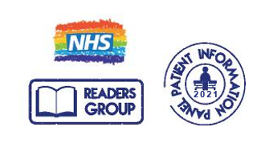
Website: www.sath.nhs.net

Information Produced by: Patient Access
Date of Publication: Aug 2025 Version: 2

Due for review on: Aug 2026 ID:
@SaTH NHS Trust
Our Vision: To provide excellent care for the communities we serve

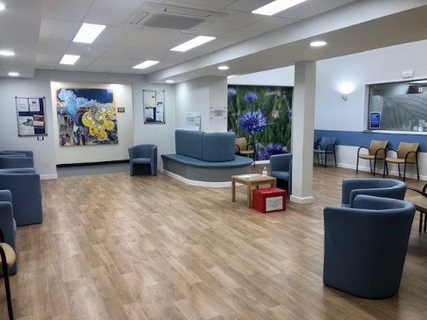
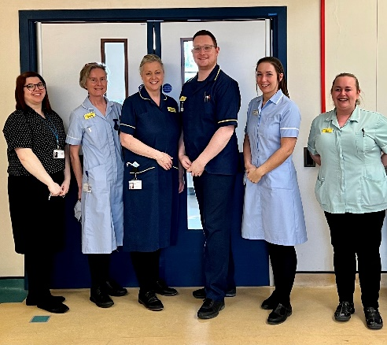
You have a health condition called MGUS (Monoclonal Gammopathy of Unknown Significance).
This is a benign disorder (not cancer) but there is a small risk this can become cancer in later life. You will be monitored by regular blood tests to check for any changes. For this reason, you have been referred to the MGUS Remote Monitoring Pathway.

What is Remote Follow Up?

Remote follow-up means you do not have to come to hospital for appointments. We can check your blood results remotely without needing to see you in person. We will send you a blood test form in the post. You can have the blood test at your GP surgery or at a hospital blood test department. We will let you know the results by letter.
If there are changes in your blood test results it does not mean you need treatment. We might want to check your blood results more often, speak to you over the phone or see you in person.

How do I arrange a blood test?
To arrange blood tests, contact your GP surgery or:

Phone – 01743 492510
Email – www.sath.nhs.uk/bloodtests

Will I still be able to access the Haematology service?
If you have any questions, you can call our Navigator on the Helpline 01743 261000 Ext 2463. You can telephone from 9am to 5pm Monday to Friday. Outside of these times you will be able to leave a message (including your name and hospital number).
If the clinical team feel you need to be seen, you will be offered an appointment.

If you have any of the signs or symptoms below, then contact the Navigators.

- General health is getting worse.
- Pain, particularly in your back or ribs
- Tiredness
- Having infections often that do not clear easily.
- Bone breaking easily.
- Swollen legs or tummy
- Feeling out of breath
- Bruising or bleeding
- Numbness or tingling in the feet, hands, or legs.
- Weight loss for no reason

Please contact us if you have any new problems or concerns.

If you need urgent medical help, call NHS 111. For medical problems which are not to do with your Haematology health problem contact your GP or NHS 111 out of hours.

