
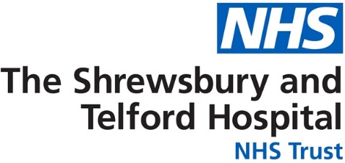
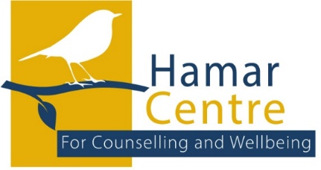

Hamar Centre For Counselling and Wellbeing
SELF - REFERRAL FORM

The Hamar Centre offers patients, individual or couples counselling, specifically regarding a diagnosis of cancer.
To be eligible you will need to be:
- Under the care of The Shrewsbury & Telford Hospital NHS Trust
- Aged 18 years or over.
- Counselling must be primarily related to your illness.
- Registered with a GP in the Shropshire, Telford, Wrekin, or Powys area.
- Receiving treatment or having last received treatment for cancer within the past 18 months. This does not include when you are receiving ongoing maintenance treatment, e.g. hormone therapy.

Please note we are not an emergency service and operate Monday- Friday 9am – 5 pm.
If you need to access more urgent support, please consider the following:
- Request an urgent appointment with your GP.
- Contact the Mental Health Access Team Tel: 0808 196 4501
- Call NHS 111
- Attend your local A& E Department
- Contact the Samaritans Tel: 116 123 (Available: 24 hours / 365 days)
If you have any questions around the referral process, please contact us on: 01743 261035.
By submitting a referral, you consent for us to share information on our systems and agree to us contacting you. (For further information please request a copy of our privacy statement.)
NB Please only refer yourself if you are not receiving counselling or therapy from any other service.
NB. For a referral to be processed please complete this form fully.
Thank -You
TO AVOID DELAY – PLEASE ENSURE ALL OF THIS FORM IS FILLED IN
Date

Your Information
Name
Address
Postcode
Date of birth
Hospital No
NHS Number

Email Address

Home Phone
Mobile Phone
Permission to leave a message (Yes or No)
Next of Kin (and relationship to you)
Contact number for Next of Kin
Other relevant medical conditions (e.g., asthma, insulin dependent diabetes, epilepsy etc)

Name of GP and Practice
Practice Address

G.P. Contact Number
About Your Situation
Current Diagnosis & Date of diagnosis
Current / Recent Treatment

Why do You wish to access counselling?

Additional Information (is there anything else you think it would help us to know about you or your situation)

Have you accessed our services before?
If so, when was this?
Have you experienced counselling in the past?
Are you currently receiving counselling or mental health support from any other service?

Please Email this form to: sath.hamarcentre@nhs.net
Or post to: The Hamar Centre, Royal Shrewsbury & Telford Trust, Mytton Oak Rd. SY3 8XQ
OFFICE INFORMATION ONLY
Date Referral received
Date Client contacted and offered appointment.

Patient not responded to contact.

Date Assessment offered
Time between Referral and assessment date | 1 week Over 4 weeks  2 weeks  3 weeks  4 weeks
Patient’s preferred method of contact | Mobile Email  Landline
Previous Counselling Notes | YES NO
Allocated Counsellor
Outcome of assessment | Counselling Offered  Did Not Attend Assessment  Referred to other service.  Declined offer & Reason:
Number of sessions attended.

Number of Sessions not attended (DNA)
Has discharge measure been given.
Date:

Has discharge measure been returned.
Date:

Has Feedback form been Given/ Sent

